02/10/2019

HUSEYIN KEREM MICAN

My father bought me my first computer when I was eight. I started playin games with it and I played a lot of games up to this age. Then I had an interest in computers and their way of working.

When my high school was finished I wanted to go to Sehir University because of its proffessors and its campus. My interest in programming had increased and I wanted to learn programming languages. Because of this I choose my department which is computer engineering and what I want from my department is to develop my computer skills as in computer’s hardware and programming.

And I would like to gain experiment and good friends. I want to gain experience by working somewhere related to my department while studying and gain friends from my department and also from Sehir University.

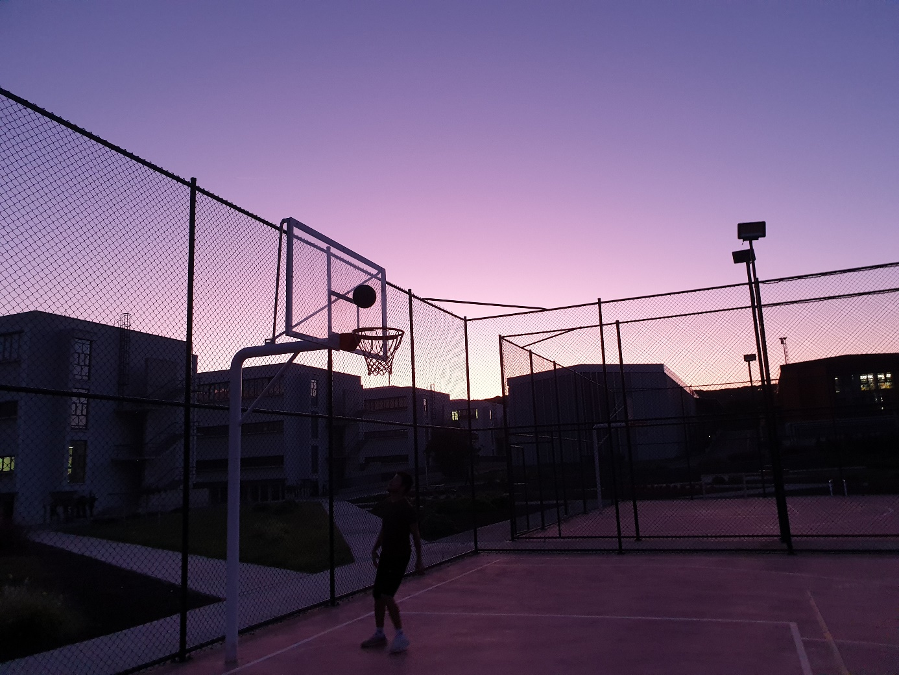

This is a beatiful sunset from our university.